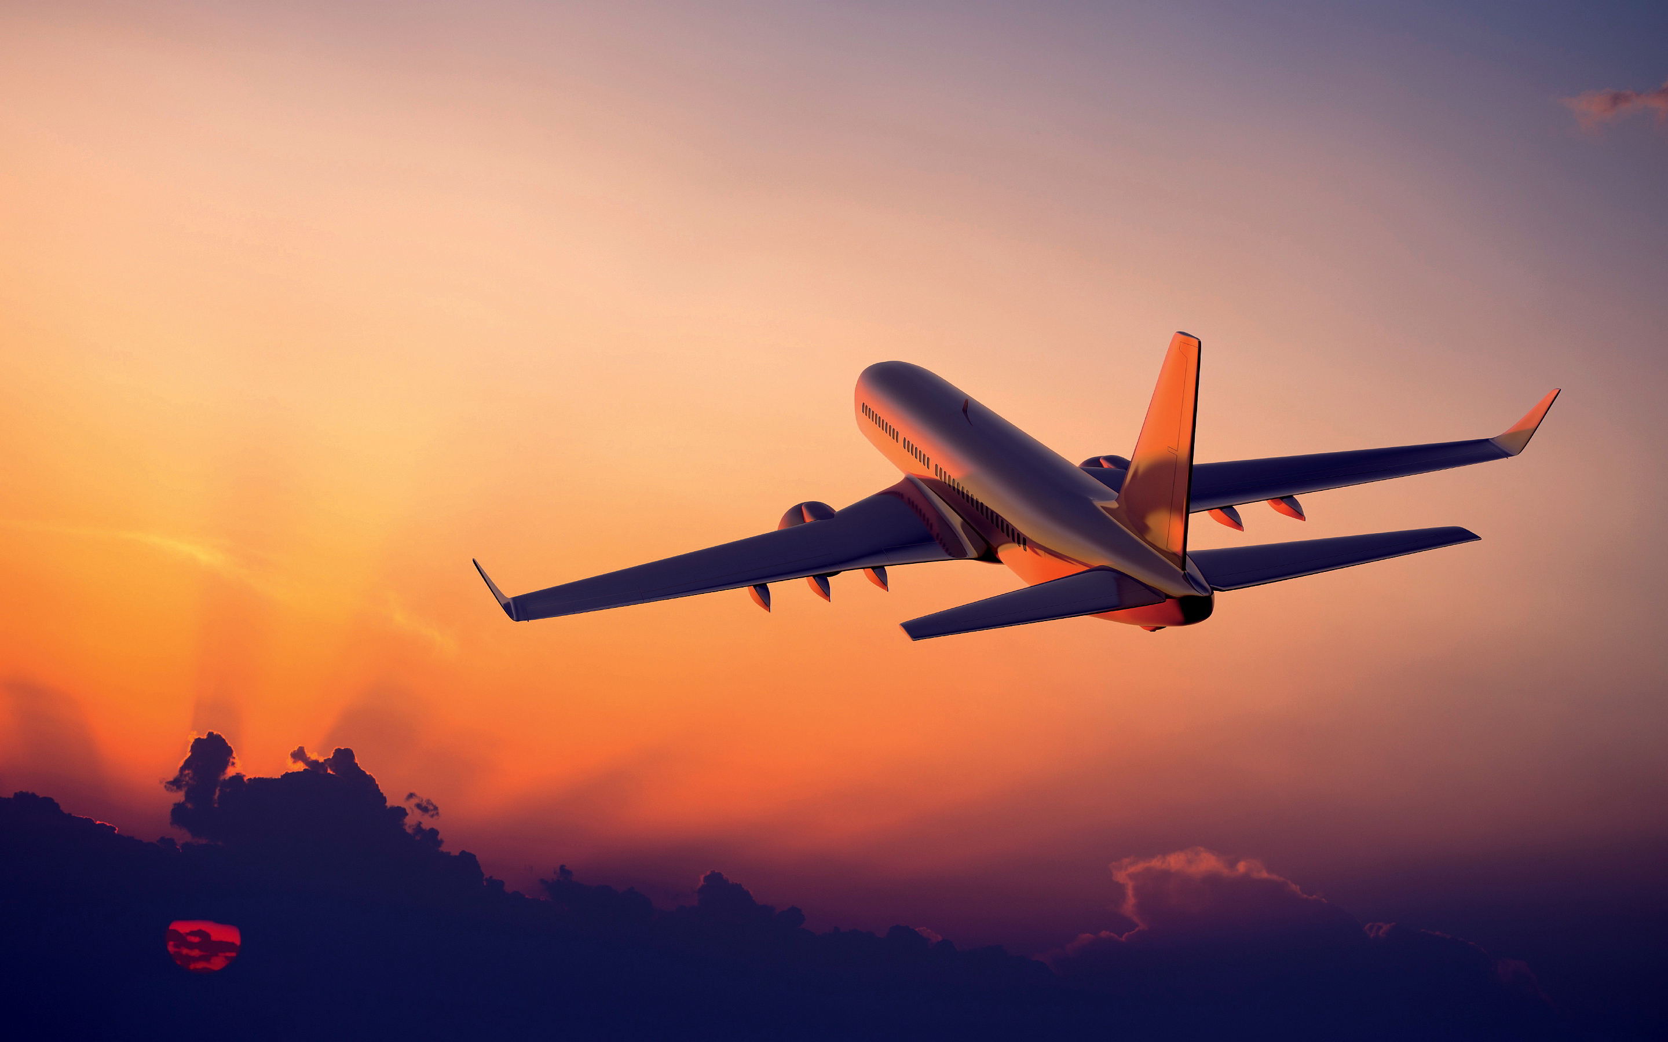

FLIGHT

U.S HISTORY REPORT

THE HISTORY OF

“The richest information about the history of flight”

Written by Phoudthaxay Sisomboun

Copyrights © 2016

All rights reserved.

HOW DID WE LEARN TO FLY LIKE THE BIRDS?

Myths and Legends of Flight:

• Greek Legend – Pegasus

Bellerophon the Valiant, son of the King of Corinth, captured Pegasus, a winged horse. Pegasus took him to a battle with the triple headed monster, Chimera.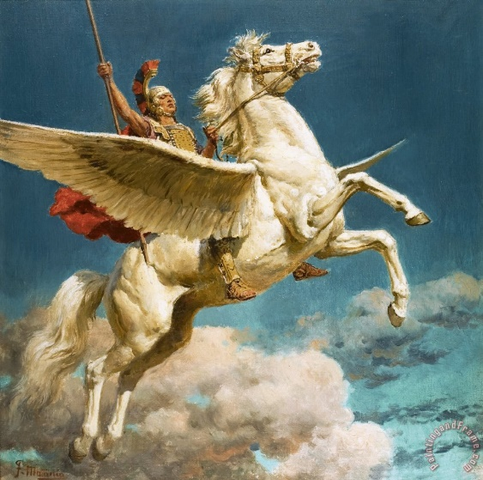

• Icarus and Daedalus – An Ancient Greek Legend

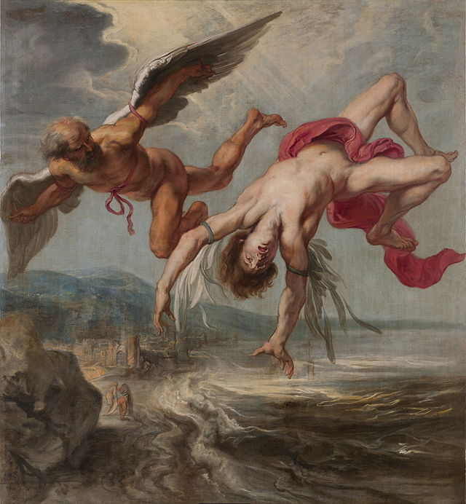Daedalus was an engineer who was imprisoned by King Minos. With his son, Icarus, he made wings of wax and feathers. Daedalous flew successfully from Crete to Naples, but Icarus, tried to fly high and flew too near to the sun. The wings of wax melted an Icarus fell to his death in the ocean.

• King Kaj Kaoos of Persia

King Kaj Kaoos attached eagles to his throne and flew around his kingdom.

• Alexander the Great

Alexander the Great harnessed four mythical wings animals, called Griffins, to a basket and flew around his realm.

**Early Efforts of Flight**

• Around 400 BC – China

The discovery of kite that could fly in the air by Chinese started humans thinking about flying. Kites were used by the Chinese in religious ceremonies. They built many colourful kites for fun, also. More sophisticated kites were used to test weather conditions. Kites have been important to the invention of flight as they were the forerunners to balloons and gliders.

• Humans try to fly like birds

For many centuries, humans have tried to fly just like the birds. Wings made of feathers or light weight wood have been attached to arms to test their ability to fly. The results were often disastrous as the muscles of the human arms are not like a birds and cannot move with the strength of a bird.

• Hero and the Aeolipile

The ancient Greek engineer, Hero of Alexandria, worked with air pressure and steam to create sources of power. One experiment that he developed was the aeolipile which used jets of steam to create rotary motion.

Hero mounted a sphere on top of a water kettle. A fire below the kettle turned the water into steam, and the gas traveled through pipes to the sphere. Two L-shaped tubes on opposite sides of the sphere allowed the gas to escape, which gave a thrust to the sphere that caused it to rotate.

• 1485 Leonardo da Vinci - The Ornithopter

Leonardo da Vinci made the first real studies of flight in the 1480's. He had over 100 drawings that illustrated his theories on flight.

The Ornithopter flying machine was never actually created. It was a design that Leonardo da Vinci created to show how man could fly. The modern day helicopter is based on this concept.

• 1783 - Joseph and Jacques Montgolfier- the First Hot Air Balloon

The brothers, Joseph Michel and Jacques Etienne Montgolfier, were inventors of the first hot air balloon. They used the smoke from a fire to blow hot air into a silk bag. The silk bag was attached to a basket. The hot air then rose and allowed the balloon to be lighter-than-air.

In 1783, the first passengers in the colorful balloon were a sheep, rooster and duck. It climbed to a height of about 6,000 feet and traveled more than 1 mile.

After this first success, the brothers began to send men up in balloons. The first manned flight was on November 21, 1783, the passengers were Jean-Francois Pilatre de Rozier and Francois Laurent.

• 1799 - 1850's - George Cayley

George Cayley worked to discover a way that man could fly. He designed many different versions of gliders that used the movements of the body to control. A young boy, whose name is not known, was the first to fly one of his gliders.

Over 50 years he made improvements to the gliders. He changed the shape of the wings so that the air would flow over the wings correctly. He designed a tail for the gliders to help with the stability. He tried a biplane design to add strength to the glider. He also recognized that there would be a need for power if the flight was to be in the air for a long time.

Cayley wrote On Ariel Navigation which shows that a fixed-wing aircraft with a power system for propulsion and a tail to assist in the control of the airplane would be the best way to allow man to fly.

**19th And 20th Century Efforts**

• 1891 Otto Lilienthal

German engineer, Otto Lilienthal, studied aerodynamics and worked to design a glider that would fly. He was the first person to design a glider that could fly a person and was able to fly long distances.

He was fascinated by the idea of flight. Based on his studies of birds and how they fly, he wrote a book on aerodynamics that was published in 1889 and this text was used by the Wright Brothers as the basis for their designs.

After more than 2500 flights, he was killed when he lost control because of a sudden strong wind and crashed into the ground.

• 1891 Samuel P. Langley

Samuel Langley was an astronomer, who realized that power was needed to help man fly. He built a model of a plane, which he called an aerodrome, that included a steam-powered engine. In 1891, his model flew for 3/4s of a mile before running out of fuel.

Langley received a $50,000 grant to build a full sized aerodrome. It was too heavy to fly and it crashed. He was very disappointed. He gave up trying to fly. His major contributions to flight involved attempts at adding a power plant to a glider. He was also well known as the director of the Smithsonian Institute in Washington, DC

• 1894 Octave Chanute

Octave Chanute published Progress in Flying Machines in 1894. It gathered and analyzed all the technical knowledge that he could find about aviation accomplishments. It included all of the world's aviation pioneers. The Wright Brothers used this book as a basis for much of their experiments. Chanute was also in contact with the Wright Brothers and often commented on their technical progress.

Orville and Wilbur Wright and the First Airplane

O

rville and Wilbur Wright were very deliberate in their quest for flight. First, they read about all the early developments of flight. They decided to make "a small contribution" to the study of flight control by twisting their wings in flight. Then they began to test their ideas with a kite. They learned about how the wind would help with the flight and how it could affect the surfaces once up in the air.

The next step was to test the shapes of gliders much like George Cayley did when he was testing the many different shapes that would fly. They spent three years testing and learning about how gliders could be controlled at Kitty Hawk, North Carolina.

They designed and used a wind tunnel to test the shapes of the wings and the tails of the gliders. In 1902, with a perfected glider shape, they turned their attention to how to create a propulsion system that would create the thrust needed to fly.

The early engine that they designed generated almost 12 horsepower. That's the same power as two hand-propelled lawn mower engines!

The "Flyer" lifted from level ground to the north of Big Kill Devil Hill, North Carolina, at 10:35 a.m., on December 17, 1903. Orville piloted the plane which weighed about six hundred pounds.

The first heavier-than-air flight traveled one hundred twenty feet in twelve seconds. The two brothers took turns flying that day with the fourth and last flight covering 850 feet in 59 seconds. But the Flyer was unstable and very hard to control.

The brothers returned to Dayton, Ohio, where they worked for two more years perfecting their design. Finally, on October 5, 1905, Wilbur piloted the Flyer III for 39 minutes and about 24 miles of circles around Huffman Prairie. He flew the first practical airplane until it ran out of gas.

**“Humankind was now able to fly! During the next century, many new airplanes and engines were developed to help transport people, luggage, cargo, military personnel and weapons. The 20th century's advances were all based on this first flights by the American Brothers from Ohio”**